Gina Foster
Dr. Harris
ENGL 4410-01
29 November 2015
Irish Subjugation and its Relation to Language and Identity
This project will explore 17th and 18th century Irish history, focusing on their colonization and subjugation by England, specifically during the Cromwellian Period. This paper will serve as foundational work for a larger capstone project planned for next semester. For this project, focusing on the Cromwellian Period and the Irish Plantations will allow a close look at the manner and effects of subjugation during 17th century England. The story of Irish persecution, however, begins further back with the papal bull, Laudabiliter, issued by Pope Adrian IV in the 12th-century, giving Henry II permission to conquer Ireland, and consequently, strengthening the Papacy’s control over the Irish Church (Harris). For the purpose of this paper, highlighting the Cromwellian Conquest will draw attention to a pivotal point of disruption in Irish identity, as Cromwell attempted to rid Ireland and England of the Irish-Catholic.
Narrowing the focus to the Cromwellian Period, illuminates this time period as a crucial turning point in England’s resolve to conquer and exterminate their Irish neighbors. Exploration is the main purpose of this project, uncovering links between empire, colonialization, globalization, and language. The work accomplished in this project will provide a launching pad for next semester’s capstone, which will, in turn, provide direction for any future graduate studies in the area of Irish Studies or perhaps Ethnolinguistics, depending on how my research and interests lead me. A presentation of the Cromwellian Period will lead into an unfolding of language based research and its correlation to relationship, geography, and culture. From there, a consideration of the psychology of language and its link to culture—a preliminary survey of the field of ethnolinguistics, looking for links to the Irish experience.
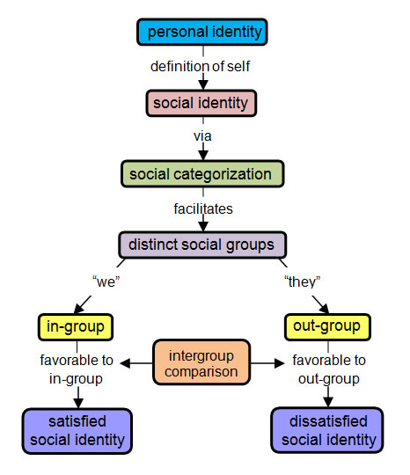
Language and identity are intimately tied. In simple terms, identity is defined as who an individual is, the way the individual thinks about himself, the way the individual is viewed by the world and the characteristics that define an individual, such as gender, race, language, ethnicity, and sexual orientation. Language plays a significant part of identity as it is a marker of social identity, ethnic identity, and national identity. Language does more than communicate information between speakers—it is a means of asserting one’s identity (Jaspal). Language can bind or divide a group, and its prominence has the power to displace other identities, such as ethnic or religious (Jaspal). Social identity refers to ones’ self-image based on how one identifies themselves with a particular group. Self-esteem and pride stem from the belonging of a group says Henri Tajfel, British social psychologist, who proposed that the groups to which one belongs are an important source of pride and self-esteem for an individual. In his Social Identity Theory, Tajfel describes ones desire to have a positive self-image through membership within a social group. Tajfel asserts that there are three cognitive processes that an individual undergoes in identifying the ingroup of which one belongs and the out-groups of which one does not. Social identity is used to categorize people into groups, help them identify with certain groups, and compare the groups one belongs (ingroups) to groups that one does not (outgroups). Tajfel makes the point that individuals usually think more highly of their own in-group in comparison to the out-groups. The central hypothesis of social identity theory is that group members of an in-group will seek to find negative aspects of an out-group to enhancing their self-image. In order to increase self-image, one enhances the status of their ingroup (McLeod). For example, Georgia Gwinnett College is the best college in the world! This process of comparison is a key component to Tajfel’s theory. Tajfel also contends that an individual will attempt to enhance their self-image by discriminating or holding prejudice views against the out-groups. When we consider this through the lens of the Irish population in the medieval time period, we notice an establishing of them as ‘other,’ or an out-group in the eyes of their English neighbors. Henry II established a bridgehead in Ireland, called the Pale, from Dublin to Drogheda, and over time English settlers would move in. With them they brought their language and customs. Giraldus Cambrensis, a twelfth century Welsh churchman, ventured to Ireland with Henry II, and later wrote Topographia Hiberniae (The History and Topography of Ireland), describing the geography and culture of Ireland. He detailed the landscape as well as the character of the Irish people, whom he called barbarians, drunkards, even cannibals, thus contributing to the formation of negative attitudes toward the Irish and planting seeds of animosity within the English. The lords of the Pale, those descendants of earlier Norman invaders who lived in and around Dublin, lobbied the crown in the sixteenth century to suppress the growing power of their Gaelic neighbors. It was these men, contends Karl Bottigheimer, who planted negative images of the Gaelic Irish in the ‘new English’ mind. Thus, in his words, ‘A considerable part of the “English image of Ireland” was . . . manufactured in the Pale, and reflected less the ignorant prejudice of metropolitan Englishmen than the calculated snobbery of a struggling elite within Ireland (Kane 448).
Figure 1-Social Categorization, Identification, and Comparison is the process of social identifying described by Henri Tajfel in his Social Identity Theory.
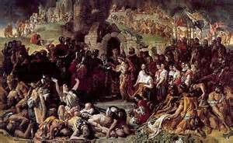
This attitude is a seed of Ireland’s subjugation. The English attitude toward the Irish as ‘other,’ a barbaric population to be conquered and subdued as well as the Irish attitude towards itself contribute to the long process of the subjugated Irish. Just as American students know the year 1776 as freedom from England, the Irish student should know 1166 as subjugation to it. The Irish King of Leinster, Diarmait MacMurchada, was ousted from his kingdom by Tigernán Ua Ruairc and Ruaidrí Ua Conchobair when the High King of Ireland was killed and Ruaidrí Ua Conchobair took his place. Seeking help to regain his kingdom, MacMurchada crosses the Irish Sea for help from Henry II. Henry’s involvement marked the beginning of England’s political involvement in Irish affairs (McCaffrey). The English took the appeal for aid as an opportunity to exercise power over who they saw as a weaker entity. The English would over the following centuries feel it their right to invade, impose, and “civilize” Ireland by planting their own people, language, and religion there.
Figure 2-Diarmait MacMurchada ), King of Leinster, and his wife Mor O’Toole
The early plantations in Ireland were of two different types: instructional and punitive. Instructional plantations were meant to teach the Irish agricultural techniques. Punitive plantations—ones that would ultimately prevail in Ireland and the Americas—were established as punishment of the Irish who rebelled against English law. Before venturing into the plantation of Ireland, I want to explore the origins of the concept of plantations. In Origins of the Colonial Idea in England, Harvard English Professor Howard Mumford Jones states that the terms customary in sixteenth and seventeenth century writing about overseas settlements were “colony” and “plantation.” Jones suggests that these were novel words because there is “no evidence that English thinking about colonization was influenced by Greek or Roman theory;” however, he did cite an 1867 Bannatyne Club Publication article entitled “Royal Letters, Charters, and Tracts Relating to the Colonization of New Scotland” that states: “The Romans did build some Townes which they did plant with their own people by all rigour to curbe the Natives next adjacent thereunto…” (Jones 448) Curbing the natives was exactly what the English had in mind for the Irish. In an attempt to hold Irish land, the English began planting colonies in Ireland. In 1553, during the reign of Queen Mary, who succeeded Edward VI, the treatment of the Irish territories changed. Before, the English would topple a troublesome Irish chief and put a submissive English or Anglo-Irish in his place. The change occurred when England decided that upon overthrowing a rebellious chief, his lands and that of all his people would now be confiscated by the crown and given to English adventurers, often referred to as “undertakers.” Chosen were those undertakers who agreed to populate the seized land with several English or Scotch settlers. Of course, the undertakers were left with the task of clearing off the native Irish. Interestingly, this situation seems to be the same situation colonists underwent with the Native Americans.
Plantations were not simply a means to colonize. The Irish grew resentful toward the fact that their religion was being highly infringed upon. Backing up a bit, history shows us that Christianity was a large part of the Irish culture, beginning with its monastic mode of ministry. Authority did not lie in an organized religious entity or government establishment; the local monasteries offered service, spiritual guidance, and even education to the communities. The Norse invasions would severely bring damage to this system. The Roman Church, who became aware through Canterbury in England, that the weak system of the Irish would not hold, began influencing the Irish, and by the 12th century, complying with Rome was common practice. There were no more native liturgies; the liturgy of the English Church took life. Throughout the medieval period, Englishmen were appointed to the more important positions in the Irish Church (“Church of England”).
Losing power over their religious practice sprung up early, again because of another’s—the Norse—self-appointed right to invade. Because the full scope of this aspect of Irish history need not be detailed for the purpose of this project—although it is tempting—I will not outline more specifics as to other invasions between the early Norse and Oliver Cromwell’s 17th century English invasion, which we will look at soon. It is in the Cromwellian Period that the Irish endured a concentrated campaign of their eradication. The onset of Cromwell’s wrath was ignited by a rebellion enflamed by resentment toward the planting of the English and the threat toward the Irish religion—Catholicism—and the Irish language. In 1641 a rebellion broke out lead by the Earl of Tyrone, Phelim Hugh O’Neill, in response to the rate of English Protestant plantation growth in Ireland. The Catholic Anglo-Irish aristocracy and native Irish insurgents lashed out in resentment of English law and Protestantism and began attacking plantation settlers throughout Ireland, most severely in Munster and Ulster (Plant). What began as a rebel Irish Catholic movement grew into an organized Irish Catholic Confederation with its own government and military force. The efforts of the Confederation was the greatest attempt by the Irish Catholic majority to take back their land and most importantly—their religion. The Confederates’ hope was that the Royalists and Charles I, to whom they pledged allegiance because he had no qualm with the Catholic who was obedient to his rule, would be victorious in the English Civil War against the Parliamentarian Protestants. But the defeat of the Royalists and beheading of Charles I would only bring about an English Commonwealth and Protectorate that would be ultimately ruled by English Commonwealth military leader and converted Puritan, Oliver Cromwell, who landed on Irish soil in 1649 to crush the Confederation and murder and enslave thousands of Irish Catholics.
During the sixteenth and seventeenth centuries, the English dominated Ireland as it exercised confiscations of Irish Catholic owned land, which were “planted” with settlers from England and Scotland. The impact of these ‘plantations’ brought about significant changes for the Irish, politically and culturally—including the severe decline of the Irish language. They were also punitive measures that were taken in response to attempted rebellions. To the English monarchy and parliament, the wild Irish were savages meant to be subdued, tamed and Christianized. To Oliver Cromwell—Lord Protectorate, interruption between kings, and religiously reformed Puritan—they were meant to be exterminated.
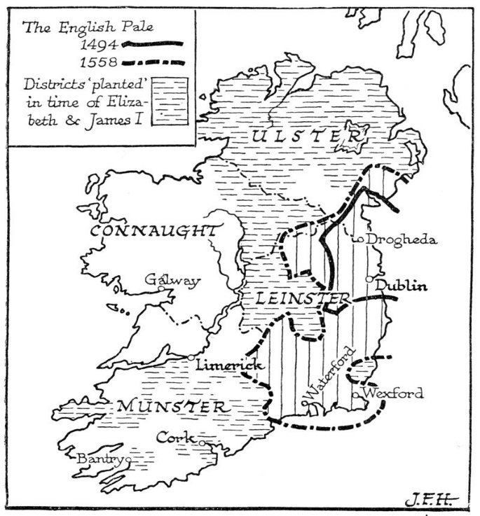
Oliver Cromwell and his New Model Army landed in Dublin in 1649, launching the Cromwellian conquest. Cromwell personally held all Irish Catholics liable for the rebellion of 1641 and the atrocities that occurred in the massacres in the Munster and Ulster Plantations. English Parliament called for the surrender of the Catholics and Royalists in Ireland and published punitive terms for mass confiscation of all Catholic lands, lashing out to suppress the rebellion and regain control of Ireland. Attacking Drogheda first, Cromwell massacred 1,000 Irish troops and 3,000 civilians. He sold the survivors into slavery. He went on to justify his action as “a righteous judgment of God upon
Figure 3-The Pale was a bridgehead initially established by Henry II.
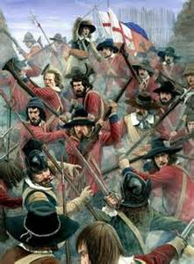
those barbarous wretches who have imbrued their hands in so much innocent blood ’and argued that‘it will tend to prevent theeffusion of blood for the future’ (Ranelagh ). Storming along the Pale, he besieged Duncannon, Kilkenny, Clonmel, Munster and Cork, Wexford, and Waterford. Unable to overtake the forces in Limerick and Galway, he penned them in until they surrendered—hunger and disease driving them out. By 1651, there was an end to organized warfare and the Irish resorted to guerilla warfare. Cromwell and his army started destroying their food supplies and scorching the land. War, famine, and plague ravished Ireland as the Irish paid for their rebellion and their Catholicism. In an effort to clear Ireland for English settlement and control, able-bodied Irishmen were captured and shipped off to fight overseas wars for the English. According to Don Jordan and Michael Walsh, authors of White Cargo: The Forgotten History of Britain’s White Slaves in America, 12,000 Irish men, women, and children were shackled and chained, led below decks, and shipped to the West Indian colonies. Nearly 34,000 went into exile in Spain and France. The Long Parliament, committed to the mass confiscation of Irish Catholic land for preparation of mass English settlement, passed three acts: The first of these, the Adventurers' Act of 1642, offered English settlers confiscated Irish land. The second, the Act for the Settling of Ireland of 1652, stated the penalties for not adhering to English law, and the third: the Act of Satisfaction of September 1653, which detailed the final plan for English plantation and Irish relocation. The Irish Civil Survey of 1654-1655 gathered information on the value and ownership of tracts of land, and more than 12,000 veterans of the New Model Army received land as payment for their service. Some settled and married Irish woman; others sold their grants to Protestants.
Figure 4-Drogheda, September 11, 1649. English troops storm catholic and royalist. Hmmm...9/11...
Once Cromwell pacified the Irish and Royalist forces, he passed a series of penal laws against Irish Catholics, which included banning Catholics from holding office in the Irish Parliament. Any Catholic landowner who had participated in the Confederate Wars were stripped of their lands and deported to the West Indies as slaves. They could not live in towns. Catholic clergy were expelled from the country and Catholic Mass was illegal. The land of other Catholic landowners was also seized, and they were pushed west, between the Atlantic Ocean and the River Shannon where the land was of far less value than the lands they had forfeited. This pinning between the waters was an act of power in order to control the Catholic landlords. The percentage of Catholic landowners in the country dropped from 60% of the population to just 8%. About a third of the Irish Catholic population had been murdered or exiled. The Penal Laws prohibited Catholics from teaching their children, entering into mixed marriages, inheriting property over a Protestant heir, possessing arms or a horse worth more than £5 or holding leases for more than 31 years; Catholics could not make a profit greater than a third of their rent; no Catholic could hold a seat in the Irish Parliament, hold public office, vote, or practice law. Cases against Catholics were tried without juries, and bounties were given to informers against them. Many Catholics felt they had no other choice but to convert or emigrate. The Irish Catholic—which was the overwhelming majority of Ireland’s population—lost their right to self-determination. The plantations and penal codes had a profound impact on Ireland, as a whole. Everything that was natural to them, identified them as Irish was yanked —their land, their religion, their native ruling class, their clan culture, even their language. English was the language of law, the language of commerce, the language of power.
Drawing all of this back to the issue of language and suppression, let us summarize the atrocities brought onto the Irish short of their death. Under the plantation system, England was essentially making Ireland English. In order to do so, the Irish had to be stripped of power—and stripping away power means stripping away identity. Recall the identity markers discussed earlier—social, ethnic, and national—all of which are language markers. It draw specific attention to the aspect of language, as a reminder that this project is a laying of foundation for next semester’s capstone project on ethnolinguistics and language loss. Here is an abbreviated and simplistic version of what the Irish endured as a result of the plantation and settlement of their land (Keep in mind that the penal laws were largely directed at the Irish Catholic population and that population consisted almost entirely of Catholics): they were uprooted and moved—to another part of their island or to the Caribbean Islands; they were denied their religion; they were denied education; they were denied profession; they were stripped of property rights; they were stripped of political rights—they could not hold office or vote; the law, religion, education, and all aspects of power were saturated with a foreign language—English. Again, I highlight this as the connection between subjugation and loss of language and identity.
So how does all this suppression specifically affect identity? I will correlate the answer and lay it out simply as I did the suppression. Uprooting and moving lends to a loss of “a sense of place.” The famous Irish poet Seamus Heaney contemplates this phenomena in much of his work. In regards to the ripping of religion from the Irish, faith and a belief system is not just a group identifier, it is also an intimate, personal, individual identity marker. Of all things robbed from the Irish, the heart issue of faith could never be taken away. Perhaps this is why religion is such a national marker for them—superseding language even (something to explore in the capstone project). The denying of education, profession, political office, etc. pinned the Irish to a lower socio-economical class and poverty. The lack or presence of education creates class distinction, which creates division, which further solidifies out-groups, breeding prejudice. In other words, this classification affects the attitudes of how others viewed an individual and how the individual viewed himself. Recalling what we learned about social identity, an individual will make adaptations to pull himself into a more desirable social identity. Stripping away the rights to education, profession, and political power denies individuals their “voice.” In the case of the Irish, it was literally their Irish voice that decayed. All of these point at the powerless position of no self-determination.
Explaining briefly—leaving the bulk for more in-depth research—let us project some specifics on how the impact on identity affects language. Again, I will parallel the explanation with the simple layout of above. Being uprooted means moving to an area within one’s own country that probably uses a different dialect, which can be problematic in communication. Being uprooted and moved overseas, one will more than likely be immersed in a completely new language. Both these scenarios ban be intimidating, frustrating, and frightening—all postures of powerlessness. Stripping away religious rights and offering rights to another religious sect puts an individual in the position of “no choice” but to abandon their preferred religion and convert to the other. Because the Irish language marked individuals as Irish (and Catholic, for the majority), an individual’s language would be a “noose around their neck.” In order to escape this, an individual would have “no choice” but to abandon their language and adopt the language of power. Also, speaking the language of the lower class applies stigma, again pinning an individual to a position of no power. Sadly, as a result, resentment may brew up in an individual against his own native language, not to mention the contempt others have toward the individual because of their social class. An individual has “no choice” but to change his language—thus changing his worldview—the principle of Linguistic Relativity states that the structure of a language affects the ways in which its respective speakers conceptualize their world, i.e. their world view, or otherwise influences their cognitive processes. So, in short, an individual who is subjugated is forced to change their way of thinking, their own identity in order to regain rights and re-claim self-determination.
Thus far, I can logically conclude that language creates identity. Identity can attract subjugation; therefore, a subjugated identity affects language. But the bigger questions must be answered: “Why do we care?” “Why is this significant in the larger sense?” “How does it affect humanity?” These are the musings of this language and literature student. I will take my studies deeper and apply what I have learned thus far and look closer at the decay of the Irish language and how it has further impacted them and how they moved forward. Did they lose something of themselves? I will look closely at what the Irish poets and writers have to say about it all, as well.

Works Cited
Broin, Brian Ó. "The Changing Irish Language Demographic." Multilingual 24.3 (2013):
24-28. Business Source Complete. Web. 22 Nov. 2015.
Coakley, Maurice. Ireland In The World Order: A History Of Uneven Development.
London: Pluto Press, 2012. eBook Collection (EBSCOhost). Web. 20 Nov. 2015.
Eisenlohr, Patrick. “Register Levels of Ethno-national Purity: The Ethnicization of Language and
Community in Mauritius”. Language in Society 33.1 (2004): 59–80. Web.
French, Brigittine M.. “Linguistic Science and Nationalist Revolution: Expert Knowledge and
the Making of Sameness in Pre-independence Ireland”. Language in Society 38.5 (2009):
607–625. Web.
Gade, Daniel W. “Language, Identity, and the Scriptorial Landscape in Québec and Catalonia”.
Geographical Review 93.4 (2003): 429–448. Web.
Giorgi, Kyra. Emotions, Language And Identity On The Margins Of Europe. Houndmills,
Basingstoke, Hampshire: Palgrave Macmillan, 2014. eBook Collection (EBSCOhost). Web. 15 Nov. 2015.
Handman, Courtney. “Language Ideologies, Endangered-language Linguistics, and
Christianization”. Language 85.3 (2009): 635–639. Web. p.636
Hansen, Jette G., and Jun Liu. “Social Identity and Language: Theoretical and Methodological
Issues”. TESOL Quarterly 31.3 (1997): 567–576. Web.
Harris, Mary N.. “Beleaguered but Determined: Irish Women Writers in Irish”. Feminist Review
51 (1995): 26–40. Web...
Hawa, Salam. "Through The Eye Of The Other." Arab Studies Quarterly 36.3 (2014): 201-219.
MasterFILE Elite. Web. 20 Nov. 2015.
Jaspal, R. Language and social identity: a psychosocial approach. Psych-Talk, 64, (2009). 17-20.
Jones, Howard Mumford. “Origins of the Colonial Idea in England”. Proceedings of the
American Philosophical Society 85.5 (1942): 448–465. Web.
Kane, Brendan. "Ordinary Violence? Ireland As Emergency In The Tudor State." History 99.336
(2014): 444-467. History Reference Center. Web. 15 Nov. 2015.
Kinahan, Frank, and Seamus Heaney. “An Interview with Seamus Heaney”. Critical Inquiry 8.3
(1982): 405–414. Web
Laroche, Michel, Frank Pons, and Marie-Odile Richard. "The Role Of Language In Ethnic
Identity Measurement: A Multitrait-Multimethod Approach To Construct Validation." The Journal Of Social Psychology 149.4 (2009): 513-539. MEDLINE with Full Text. Web. 15 Nov. 2015.
McCaffrey, Carmel, and Leo Eaton. In Search of Ancient Ireland: The Origins of the Irish, from
Neolithic times to the Coming of the English. Chicago: New Amsterdam, 2002. Print.
McLeod, Saul. "Social Identity Theory | Simply Psychology." Social Identity Theory | Simply
Psychology. N.p., 2008. Web. 23 Nov. 2015.
McFeeters, Belinda Bennett. "Ingroups And Outgroups." Research Starters: Sociology (Online
Edition) (2015): Research Starters. Web. 15 Nov. 2015.
Nash, Catherine. “Irish Placenames: Post-colonial Locations”. Transactions of the Institute of
British Geographers 24.4 (1999): 457–480. Web.
Plant, David. "The Confederate War." British Civil Wars, Commonwealth and Protectorate
1638-1660. N.p., 23 Oct. 2012. Web. 19 Nov. 2015.
Phinney, Jean S. "Understanding ethnic diversity: the role of ethnic identity." American
Behavioral Scientist 40.2 (1996): 143+. Academic OneFile. Web. 23 Nov. 2015.
Rahman, Tariq. “Language Ideology, Identity and the Commodification of Language in the Call
Centers of Pakistan”. Language in Society 38.2 (2009): 233–258. Web.
Ranelagh, John. A Short History Of Ireland. Cambridge: Cambridge University Press, 2012.
eBook Collection (EBSCOhost). Web. 17 Nov. 2015.
Rodriguez, Jaclyn. "Social Identity Theory." Salem Press Encyclopedia of Health (2015):
Research Starters. Web. 15 Nov. 2015.
Rusinko, Elaine. The Slavic and East European Journal 55.1 (2011): 149–150. Web.
Sallauka, Diella. Personal Interview. August 31, 2015.
Valentine, Gill, Deborah Sporton, and Katrine Bang Nielsen. “Language Use on the Move: Sites
of Encounter, Identities and Belonging”. Transactions of the Institute of British Geographers 33.3 (2008): 376–387. Web.
Wales, Gerald (Giraldus) Of. The History and Topography of Ireland. Trans. John O'Meara.
Harmondsworth, Middlesex, England: Penguin, 1982. Print.
"Penal Laws." Columbia Electronic Encyclopedia, 6Th Edition (2015): 1-2. History
Reference Center. Web. 21 Nov. 2015.

